**DNFC (Group 6) SEP1 Project Description**

|  |  |
| --- | --- |
| Names of Students | Number |
| Daniel Lopes Adrião | 315274 |
| Dragos-Daniel Bonaparte | 315261 |
| Laura do Bem Rebelo | 315174 |
| Matas Armonaitis | 315263 |

**Software Technology Engineering**

**1st Semester**

**13.10.2021**

**Table of content**

1. Background Description 1

2. Problem Statement 2

3. Definition of purpose 2

4. Delimitation 2

5. Methodology 3

6. Time schedule 3

7. Risk assessment 4

8. Sources of Information 5

Appendices (including Group Contract)

# Background Description

VIA’s time schedule manager is currently unable to create timetables effectively. The reason why is because there is no existent tool that meets all the requirements requested by VIA for students and teachers’ classes to be properly scheduled and managed.

At the moment, the timetable manager uses a lengthy method to schedule classes for Software Technology Engineering students. Before the semester starts, the Head of Department provides him with a list of all courses and students for each semester, the class to which they belong to and a list with the teachers for each course and class. With that, the manager uses spreadsheets to create a timetable for every class existent in each semester. If there are students with credits for a certain course, an individual timetable needs to be created for them. It is also necessary to assess the availability of each classroom by hand. After being finished, the manager sends a draft of all the timetables to the teachers, and a “test week” is conducted. If it is approved, it is published on a shared website where they can be downloaded by students and teachers. The issue with this methodology is that it is too time consuming for one person to manually manage and arrange all the timetables for all courses of Software Technology Engineering, given all the parameters that need to be taken into account.

Moreover, in university, classes are often cancelled for various unpredictable reasons. This leaves a vacant classroom and a gap in students and teachers’ schedules. The lack of a system that properly displays this information to whoever is scheduling the classes may lead to teachers not knowing that there is an available room and giving up a class due to the inaccessibility of this information.

A possible application for the manager to use would be Google Calendars, which is easy to sync with multiple devices. However, it lacks a feature that is imperative when booking classes for VIA. The University’s new Campus has a shortage of classrooms due to the high number of students currently enrolled, and therefore it is difficult for a timetable manager to know which classrooms are available to book for a certain class. (What Can You Do with Calendar? - Google Workspace Learning Center, 2021)

In summary, the existent problem is the inefficiency of the time schedule manager in producing and providing well-organized timetables to students and teachers.

# Problem Statement

The customer would like a timetable management tool, which should increase productivity and efficiency at work. This will also benefit students and teachers who make use of these timetables.

1. What kind of information is necessary when scheduling a class?
2. What can be done for the timetable manager to know which classrooms are available when booking?
3. Where can students and teachers get access to their personal timetables?

# Definition of purpose

The purpose is to increase productivity by providing VIA’s timetable manager with a tool that will facilitate the scheduling of all students and teacher’s classes.

# Delimitation

1. The system will not include a log-in function for access.
2. The system will not be designed for other universities nor other students from VIA besides STE*.
3. The calendar will not include plans or content for the class booked, only the timeframe in which it exists.

*STE: Software Technology Engineering

*STE: Software Technology Engineering

STE

# Methodology

To manage our project, we will vaguely follow a Waterfall methodology. This includes:

* **Requirements,** which need to be well understood before moving on to any further **analysis**.
* **Design**, in which a logical design plan is formulated in accordance with the requirements established.
* **Implementation/Coding**: the stage where all the previous planning is executed through code.
* **Testing**, which is performed to assure everything works according to the project plan.

# Time schedule

Given that the expected workload is 27.5 hours per ECTS per student, we will be working a total of 275 hours per person in the group. This amounts to 1100 hours of work in the project. The workload will be spread out throughout these 10 weeks depending on the difficulty of each task.

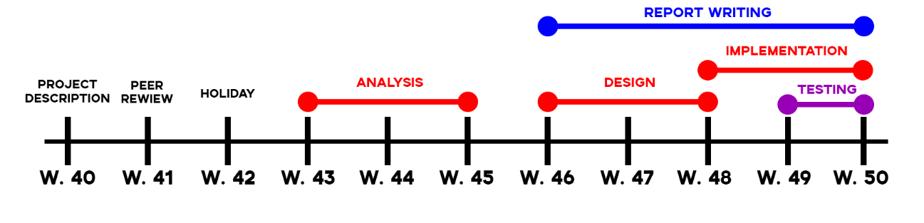

**FINAL DEADLINE TO UPLOAD:** 17 December 2021 at 13:00.

# Risk assessment

|  |  |  |  |  |  |  |
| --- | --- | --- | --- | --- | --- | --- |
| **Risks** | **Likelihood**  **Scale: 1-5**  **5 = high risk** | **Severity**  **Scale: 1-5**  **5 = high risk** | **Product of likelihood and severity** | **Risk mitigation e.g. Preventive- & Responsive actions** | **Identifiers** | **Responsible** |
| Logical flaws | 3 | 5 | 15 | Coding in pairs, and plenty of testing. | Logical flaws – the program does not work as intended. | Dragos |
| Source file incompatibility | 3 | 5 | 15 | Asking the head of department for a new compatible file or to edit the existing one. | Program cannot fetch information from Head of Department source file | Matas |
| Website compatibility issues | 3 | 3 | 9 | Paying close attention to Responsive Web Design classes, checking the website in multiple devices. | Website not displaying correctly in certain devices or browsers | Daniel |
| Inefficiency of system | 4 | 1 | 4 | Applying DMA knowledge to our logic and code, and RWD knowledge about image compressing. | Program loads slowly, affects in Bob’s time efficiency, file sizes are too big | Laura |

# 

# Sources of Information

Gaddis, T., 2015. Starting Out with Java: Early Objects. 5th ed. Boston [etc.]: Pearson.

Duckett., J., 2011. *HTML & CSS: Design and Build Websites*. John Wiley & Sons Incorporated.

Duckett, J., Ruppert, G. and Moore, J., 2014. JavaScript & jQuery.

LaGrone, B., 2013. HTML5 and CSS3 Responsive Web Design Cookbook.

Weiss, M., 2012. Data Structures and Algorithm Analysis in Java. Boston, Mass: Addison-Wesley.

Support.google.com. 2021. What can you do with Calendar? - Google Workspace Learning Center. [online] Available at: <https://support.google.com/a/users/answer/9302892?hl=en> [Accessed 8 October 2021].

W3schools.com. 2021. W3Schools Online Web Tutorials. [online] Available at: <https://www.w3schools.com/>.

**Appendices**

Group Contract

Group Name (optional): **DNFC** Date: **23/09/2021**

These are the terms of group conduct and cooperation that we agree on as a team.

**Participation**: We agree to....

Meet up on Wednesdays, assign tasks for the week and meet up whenever possible.

**Communication**: We agree to...

Use English as the group language, be transparent on what we can and can’t do, communicate through social media.

**Meetings**: We agree to....

Work together when necessary, always make progress, not be late, constantly input feedback.

**Conduct**: We agree to....

Stay focused, take breaks when necessary, ask for group input regarding decisions, keep track of progress in a meeting journal.

**Conflict**: We agree to....

Discuss the issues respectfully and prevent them from escalating to a bigger problem. If by any chance it escalates, we can contact the supervisor.

**Deadlines**: We agree to....

To have deadlines for every task, to not tolerate absences without any reason and if someone is late, they have to notify the group. To help each other to fulfill the task in the case that someone struggles and won’t be able to do the assignment in time.

|  |  |  |
| --- | --- | --- |
| **Group member’s name** | **Student number** | **Signature** |
| Matas Armonaitis | 315263 |  |
| Dragos-Daniel Bonaparte | 315261 |  |
| Laura Rebelo | 315174 |  |
| Daniel Lopes Adrião | 315274 |  |